**Key ATAR Human Biology Unit 4**

**EXTENDED RESPONSE 4: VALIDATION TEST - EVIDENCE OF EVOLUTION**

**Validation Test: _______ / 40**

**Total % _______**

**Read the text below and answer the following questions.**

Digging for dinosaur bones is a popular 'holiday' activity for adventurous visitors to outback Queensland. They're searching for large dinosaurs called sauropods.

These were land based dinosaurs and they roamed the vast forested floodplains that surrounded the inland sea that covered much of Queensland and central Australia about 95 million years ago.

Well-preserved bones and other fossilized remains of these dinosaurs have been found in the rocks underlying the Mitchell grass downs that now dominate the landscape around the town of Winton.  
This includes the remains of the largest dinosaur yet found in Australia - an animal that has been nicknamed 'Elliot'. These bones were first discovered in 1999 by local grazier David Elliott, he noticed a bone fragment on the surface of the ground as he was mustering sheep.

Scott Hocknull from the Queensland Museum says "it wasn't just any old fragment of bone that you find on the surface - this was a piece of thigh bone that measured 50cm in diameter, so you're talking about an animal with a 50cm wide knee".

Mr Hocknull describes the dimensions of this dinosaur (it was) "an animal with a four metre high rump, maybe 16 metres long and 20 tonnes in weight". "it wasn't just any old fragment of bone that you find on the surface..."The Queensland Museum has led a number of 'digs' at the Elliot site near Winton, involving the Elliott family and volunteers

1. Who am I? [1]

A sauropod dinosaur

2. Describe me. [1]

Largest dinosaur yet found in Australia, four metre high rump, 16 metres long and 20 tonnes in weight (2 points)

3. a. When did I live? [1]

95 million years ago

b. How did I die? [2]

Elliot died in a floodplain probably from old age

with the carcass being covered over with sediments

to prevent/slow scavenging/decomposition. (any 2)

4. How was I fossilised? [3]

Covered with sediments to prevent/slow scavenging/decomposition

Softer parts decay away and replaced by minerals

Further layers formed above, water is forced out

Sedimentary rock formed containing the petrified/mineralized (any 3)

5. Describe the climate and vegetation at the time I was alive. [1]

Wet & humid with vast forests

6. What events had to occur for me to be discovered? [2]

Weathering (1/2) breakdown of rock by water, wind (1/2)

Erosion (1/2) the removal of rock/sand to expose the fossil eg water, wind (1/2)

7. What can we learn from this discovery? [2]

Trends in the evolution of dinosaurs/characteristics/behaviour re this particular dinosaur (any 2 reasonable)

8. Relative dating gives: [2]

The relative age of a fossil/strata in comparison to other layers (1m)/Distribution patterns of fossils that lived previously (1m)/an idea whether a layer/fossil is older/younger than other layers (1m)/enable s a sequence of events to be established (1m) (any 2)

9. Absolute dating gives: [2]

The actual age of the fossil/layer (1m) /depending upon the half life of the radioisotope (1m)/ eg C14o or Potassium Argon (1m)

10. What are the problems associated with relative dating? [4]

Does not give an actual age, just whether the fossil/strata is older/younger (1m)

An index fossil is required for site comparison from different areas (1m)

The assumption that the environmental conditions at different sites were the SAME to form a particular common layer (1m)

Seismic events eg earthquakes, volcanic eruptions can alter the sequence of layers (1m)

Human activity eg mining, excavations can alter the sequence of layers (1m) (any 4)

11. What are the problems associated with radiocarbon dating? [3]

Eventually all the C14 radio isotope will decay to unreadable and inaccurate levels (1m)

This is 50,000 -60,000yrs (1m)

Need Carbon/organic material in the fossil/layer (1m)

Assumption that the ratio of C12 to C14 in the atmosphere has always been constant (1m) (any 3)

12. Describe and give an example of an index fossil. [2]

Extinct widespread fossils (1m) /present on the earth for a limited period of time (1m)

Eg Trilobite (lived on earth 500-300 million years ago (1m)

13. What is a half-life? [2]

The time taken for ½ the radio isotope to decay (1m)

Eg C14 5730 yrs (1m)

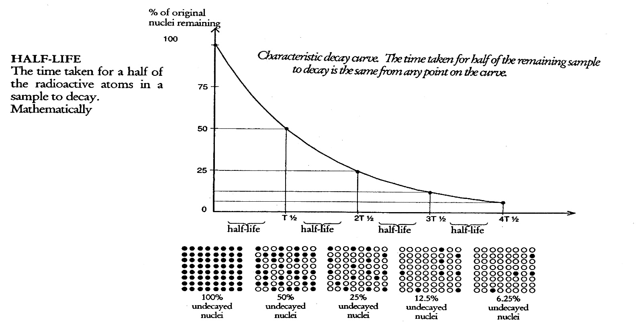14. Examine the graph below and answer the following questions.

a. How many half-lives does it take to reduce the percentage of original nuclei to 25%? [1]

2

b. If this represented a radioactive isotope with a half-life of 1300 million years, what is the age of the sample with 12.5% of the original nuclei left? [1]

3900 yrs

15. Examine the graph below and answer the following questions.

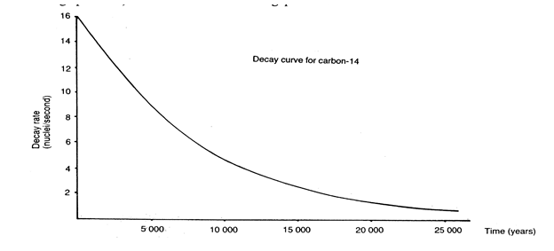

a. Calculate the age of a fossil that has a decay rate of 6 nuclei/second. [1]

8000 yrs +/- 200 yrs

b. Assuming that the half-life of Carbon-14 is 5730 years, approximately how many half-lives have passed? [1]

1

c. Which of the following could be dated with this method and why? [2]

i) An Australopithecine skull (4 million years old)

ii) A stone axe

iii) a Cro-Magnon skull (40 000 years old)

iv) A bone found in a layer above one dated at 60 000 years

v) A bone found in a layer below on dated at 100 000 years

iv) A bone found in a layer above one dated at 60,000 yrs (1m)

Because the bone is younger than 60,000 yrs (being above) and therefore within the C14 dating curve (1m)

16. Examine the picture below and answer the following questions.

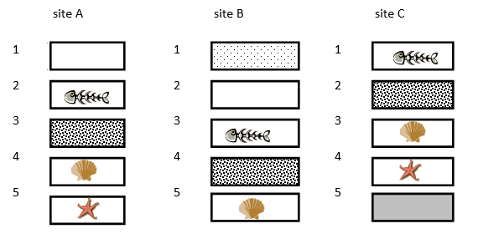

a. Which strata is the oldest of all sites? [1]

C5

b. Which strata is the youngest of all sites? [1]

B1

c. Which site gives the best representation of the oldest fossils and why? [2]

C (1m)

Because site C has one extra and oldest strata (C5) (1m)

d. Naming the strata, which fossil is present in all three sites? What can you infer from this? [2]

A2, B3, C1 (fish skeleton) and A4, B5, C4 (mollusc shell) (both for 1m)

Age at A2, B3 and C1 were the SAME **AND** A4, B5 and C4 the SAME but later (1/2m) Climatic/environmental conditions at both of these ages were the same for the fish and mollusc to be fossilized (1/2m)